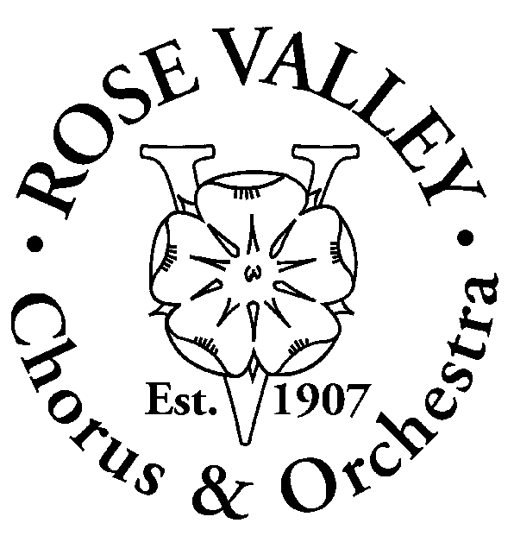
Rose Valley Chorus and Orchestra
2016 - 2017
Membership Information:
Name:
Address:

City, State, Zip:

Telephone: Home:________________________ Work:

Cell:________________________ E-mail:
Occupation, Experience, Interests:
To become a regular, active member of RVC&O, you must pay dues and participate in RVC&O productions.
Please indicate those talents you can share with the organization
PLEASE CHECK AT LEAST ONE AREA OF INTEREST UNDER ACTIVITIES
- On Stage Performer: Voice:
- Orchestra Member: Instrument:
- Show Related Activities:

- Cast Parties
- Costumes
- House Management, Refreshments, Ushering, Parking
- Lighting Crew
- Makeup
- Photography
- Playbill Production, Ads, Sponsors
- Properties
- Publicity
- Rehearsal Hospitality
- Set Construction and Painting
- Sound Crew
- Stage Crew
- Ticket Sales

- General Activities

- Business Management
- Community Outreach
- Corporate Sponsors
- Costume Production, Inventory and Organization
- Finance (Investments, etc.)
- Firehouse Maintenance and Organization
- Fundraising: (Grant Applications, Annual Appeal, etc.)
- Membership
- Publications: Writing, Graphics, Layout
- Road Shows
- Other:______________________
___________________________

Membership Dues are $25 for an entire season. Please complete this form and send it, with a check payable to Rose Valley Chorus and Orchestra, to:
Rose Valley Chorus & Orchestra
PO Box 414
Media, PA 19063

